**Notes for Web Page Design**

1. Packages page is not like requested – it should be a list of brands with a banner for each one:

1. Stars and rank section on brand page: please provide several classes for stars (6 classes, ranging from 0 to 5 full stars). **DONE (In code you just need to put the rating, the stars will generate automatically. See below)**

* 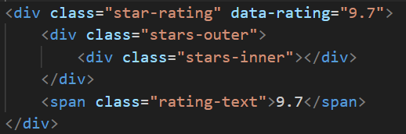
* It should look like app store – empty stars still have a frame:  **DONE**

1. Move between pages – don't use fade effect – it should be like app store – no effects when moving to another page. **DONE**
2. Clicking on "GET" on offer shouldn't direct to the brand's page – it should direct to an external link we will provide. **DONE**
3. The whole top part of the page ("featured" + "Best online casinos: our picks" + banner carousel) should be static, and not per tab. dynamic content appears only below the carousel. **DONE**

1. Claim you bonus – please use slightly smaller text and center the text **DONE**

1. Offers small text: Please make it continue in a second row if too long – don't let the text cut off with "…" **DONE**

Put just a little more space between each offer so it will be less dense. Not too much though **DONE**

